LAB MANUAL

Lab-1
Function in c++, Implementation and revision as Pre-requisites
Q. No. 1: Implement the functions as pre-requisite knowledge using C++ having following functions.
- Function declaration/definition/calling
- Function overloading
- Default function arguments
- Arguments Pass by value
- Arguments Pass by ref.
SOLUTION:
#include <iostream>
using namespace std;

void add(int a, int b);
void add(double a, double b);
void show(int a, int b = 20);
void passByValue(int x);
void passByReference(int &x);

void add(int a, int b) {
cout << "\n--- Function Overloading (int) ---\n";
cout << "Sum of integers: " << a + b << endl;
}

void add(double a, double b) {
cout << "\n--- Function Overloading (double) ---\n";
cout << "Sum of doubles: " << a + b << endl;
}

void show(int a, int b) {
cout << "\n--- Default Arguments ---\n";
cout << "a = " << a << ", b = " << b << endl;
}

void passByValue(int x) {
x = 100;
cout << "\nInside passByValue(), x = " << x << endl;
}

void passByReference(int &x) {
x = 100;
cout << "\nInside passByReference(), x = " << x << endl;
}

int main() {
cout<<"\nTAYYABA SHFQAT (24-ARID-1087)"<<endl;
add(10, 20);
add(3.5, 2.7);

show(5);
show(5, 50);

int val1 = 10;
cout << "\nBefore passByValue(), val1 = " << val1 << endl;
passByValue(val1);
cout << "After passByValue(), val1 = " << val1 << endl;

int val2 = 10;
cout << "\nBefore passByReference(), val2 = " << val2 << endl;
passByReference(val2);
cout << "After passByReference(), val2 = " << val2 << endl;

return 0;
}
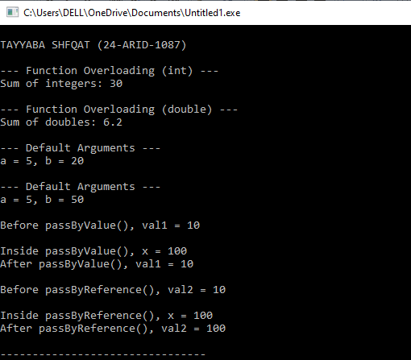

Lab-2
structures in C++, Implementation and revision as Pre-requisites
#include<iostream>
using namespace std;
struct student{
int arid_no;
string name;
float cgpa;
};
class info:public student{
public:
string degree;
int year;
};
struct person{
private:
int id;
public:
void input(int i){
id=i;
}
void output(){
cout<<id<<endl;
}
};

int main(){
student s1;
s1.arid_no=1087;
s1.name="TAYYABA SHAFQAT";
s1.cgpa=3.99;

cout << s1.arid_no <<"\n"<< s1.name<<"\n" << s1.cgpa<<endl;

info f;
f.degree="bsse";
f.name="tayyaba";
f.year=2;

person p;
p.input(12);
p.output();
return 0;}
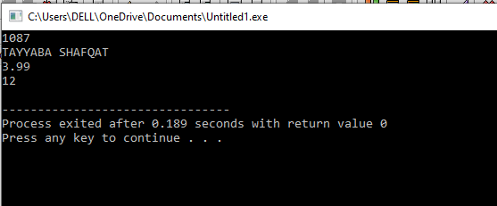

Lab-3
Implementation and Comparison of searching algorithm
#include <iostream>
using namespace std;

void searchBinary(int arr[], int n, int k) {
int low = 0;
int high = n - 1;

cout << "Values in the array:\n";
for (int i = 0; i < n; i++)
cout << arr[i] << " ";

cout << "\n\nSearching for: " << k << endl;

while (low <= high) {
int mid = (low + high) / 2;

if (arr[mid] == k) {
cout << "\nValue found at index " << mid << endl;
return;
}
else if (k < arr[mid]) {
high = mid - 1;
}
else {
low = mid + 1;
}
}

cout << "\nValue NOT found in the array!" << endl;
}
void signature(){
cout<<"TAYYABA SHAFQAT "<<endl;
cout<<"24-arid-1087"<<endl;
}

int main() {
signature();
const int SIZE = 11;
int arr[SIZE] = {2,3,5,7,9,11,13,15,17,19,21};
int k = 5;

searchBinary(arr, SIZE, k);

return 0;
}
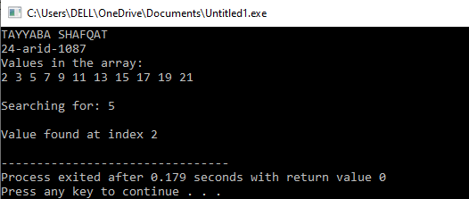

Lab-4
Implementation and Comparison of sorting algorithm
BUBBLE SORT:
#include <iostream>
using namespace std;
const int SIZE = 10;
void bubbleSort(int arr[], int n) {
for (int i = 0; i < n - 1; i++) {
for (int j = 0; j < n - i - 1; j++) {
if (arr[j] > arr[j + 1]) {
// swap
int temp = arr[j];
arr[j] = arr[j + 1];
arr[j + 1] = temp;
}
}
}
}
void signature(){
cout<<"TAYYABA SHAFQAT "<<endl;
cout<<"24-arid-1087"<<endl;
}
int main() {

int arr[SIZE];
int n, key;
signature();
cout << "Enter number of elements (max " << SIZE << "): ";
cin >> n;

cout << "Enter " << n << " numbers:\n";
for (int i = 0; i < n; i++)
cin >> arr[i];

// ?? Sort the array first
bubbleSort(arr, n);

cout << "\nSorted Array: ";
for (int i = 0; i < n; i++)
cout << arr[i] << " ";
cout << endl;

return 0;
}
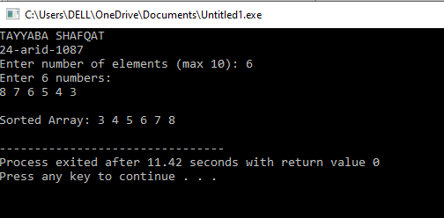
SelectionSort:
#include <iostream>
using namespace std;
const int SIZE = 10;
void selectionSort(int arr[], int n){
for(int i = 0; i < n-1; i++){
int minIndex = i;
for(int j = i+1; j < n; j++){
if(arr[j] < arr[minIndex])
minIndex = j;
}
swap(arr[i], arr[minIndex]);
}
}
void signature(){
cout<<"TAYYABA SHAFQAT "<<endl;
cout<<"24-arid-1087"<<endl;
}
int main() {
int arr[SIZE];
int n, key;
signature();
cout << "Enter number of elements (max " << SIZE << "): ";
cin >> n;
cout << "Enter " << n << " numbers:\n";
for (int i = 0; i < n; i++)
cin >> arr[i];
selectionSort(arr, n);
cout << "\nSorted Array: ";
for (int i = 0; i < n; i++)
cout << arr[i] << " ";
cout << endl;
return 0;
}

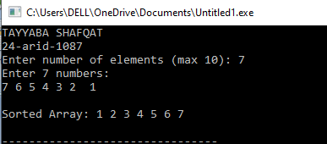

InsertionSort:
#include <iostream>
using namespace std;
const int SIZE = 10;
void insertionSort(int arr[], int n){
for(int i = 1; i < n; i++){
int key = arr[i];
int j = i - 1;
while(j >= 0 && arr[j] > key){
arr[j+1] = arr[j];
j--;
}
arr[j+1] = key;
}
}
void signature(){
cout<<"TAYYABA SHAFQAT "<<endl;
cout<<"24-arid-1087"<<endl;
}
int main() {
int arr[SIZE];
int n, key;
signature();
cout << "Enter number of elements (max " << SIZE << "): ";
cin >> n;
cout << "Enter " << n << " numbers:\n";
for (int i = 0; i < n; i++)
cin >> arr[i];
insertionSort(arr, n);
cout << "\nSorted Array: ";
for (int i = 0; i < n; i++)
cout << arr[i] << " ";
cout << endl
return 0;
}


MERGE SORT:
#include <iostream>
using namespace std;
void merge(int arr[], int left, int mid, int right) {
int n1 = mid - left + 1; // size of left subarray
int n2 = right - mid; // size of right subarray
int L[n1], R[n2]; // temporary arrays
for (int i = 0; i < n1; i++)
L[i] = arr[left + i];
for (int j = 0; j < n2; j++)
R[j] = arr[mid + 1 + j];
int i = 0, j = 0, k = left;

while (i < n1 && j < n2) {
if (L[i] <= R[j]) {
arr[k] = L[i];
i++;
} else {
arr[k] = R[j];
j++;
}
k++;
}
while (i < n1) {
arr[k] = L[i];
i++;
k++;
}

while (j < n2) {
arr[k] = R[j];
j++;
k++;
}
}
void mergeSort(int arr[], int left, int right) {
if (left < right) {
int mid = left + (right - left) / 2;
mergeSort(arr, left, mid);
mergeSort(arr, mid + 1, right);

// Merge the two sorted halves
merge(arr, left, mid, right);
}
}
void display(int arr[], int size) {
for (int i = 0; i < size; i++)
cout << arr[i] << " ";
cout << endl;
}
void signature(){
cout<<"TAYYABA SHAFQAT "<<endl;
cout<<"24-arid-1087"<<endl;

}
int main() {
int arr[] = {44, 75, 23, 43, 55, 12, 64, 77, 33};
int n = sizeof(arr) / sizeof(arr[0]);
signature();
cout << "Original Array:\n";
display(arr, n);

mergeSort(arr, 0, n - 1);

cout << "\nSorted Array using Merge Sort:\n";
display(arr, n);

return 0;
}
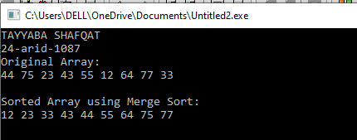

QUICK SORT:
#include <iostream>
using namespace std;

void swapValues(int &a, int &b) {
int temp = a;
a = b;
b = temp;
}
int partition(int arr[], int low, int high) {
int pivot = arr[low];
int i = low + 1;
int j = high;

while (true) {
while (i <= high && arr[i] <= pivot)
i++;
while (arr[j] > pivot)
j--;
if (i >= j)
break;
swapValues(arr[i], arr[j]);
}
swapValues(arr[low], arr[j]);

return j; // return final pivot position
}
void quickSort(int arr[], int low, int high) {
if (low < high) {
int p = partition(arr, low, high);
quickSort(arr, low, p - 1);
quickSort(arr, p + 1, high);
}
}
void signature(){
cout<<"TAYYABA SHAFQAT "<<endl;
cout<<"24-arid-1087"<<endl;
}

int main() {
signature();
int n;
cout<<"enter array size: ";
cin>>n;

int arr[n];
cout<<"enter array: ";
for (int i = 0; i < n; i++){
cin>>arr[i];
}
cout << "Original array:\n";
for (int i = 0; i < n; i++)
cout << arr[i] << " ";
cout << endl;

quickSort(arr, 0, n - 1);
cout << "\nSorted array:\n";
for (int i = 0; i < n; i++)
cout << arr[i] << " ";
cout << endl;

return 0;
}
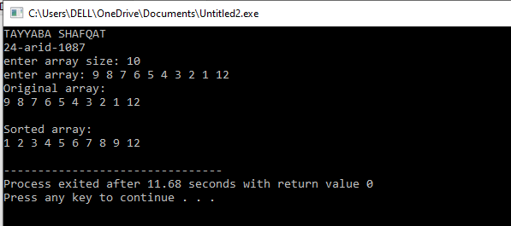

Lab-5
Implementation of Stack with arrays
Q.No.1: Implement the primitive operations of stack using a menu driven program
- Push()
- Pop()
- Isfull()
- Isempty()
- Display()

#include <iostream>
using namespace std;
const int size = 5;
struct stack {
int arr[size];
int top;
};
bool isempty(stack &st){
return (st.top == -1);
}
int isfull(stack &st){
return (st.top == size - 1);
}
void push(stack &st, int v){
if(isfull(st)){
cout << "stack is full" << endl;
return;
}
st.arr[++st.top] = v;
}
void pop(stack &st){
if(!isempty(st))
st.top--;
else
cout << "stack is empty" << endl;
}
void display(stack &st){
if(isempty(st)){
cout << "stack is empty" << endl;
} else {
cout << "the array is:\n";
for(int i=0; i<=st.top; i++){
cout << st.arr[i] << ",";
}
cout << endl;
}
}
void signature(){
cout<<"TAYYABA SHAFQAT "<<endl;
cout<<"24-arid-1087"<<endl;

}
int main(){
stack s1;
s1.top = -1;
signature();
push(s1, 4);
push(s1, 5);
push(s1, 6);
push(s1, 7);
push(s1, 8);
push(s1, 9); // should show "stack is full"
display(s1);
pop(s1);
pop(s1);
pop(s1);
display(s1);
return 0;
}
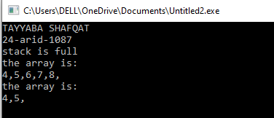

Lab 6
Infix to Post fix Conversion and Evaluation
Q. No. 1: Convert the infix expression into postfix expression using C++ and array based stack.
- Implement all the rules of infix to postfix conversion in the main() function and finally displays the postfix expression.
- Test it on two different input expressions
- C++ program to evaluate the postfix expression
#include<iostream>
#include<cstring>
using namespace std;
const int size=30;
struct stack{
int top;
char arr[size];
};
void initstack(stack &s){
s.top=-1;
}
bool isempty(stack &s){
return s.top==-1;
}
bool isfull(stack &s){
return s.top==size-1;
}
void push(stack &s, char c){
if(!isfull(s)){
s.arr[++s.top]=c;
}
}
char pop(stack &s){
if(!isempty(s)) return s.arr[s.top--];
return '\0';
}
char peek(stack &s){
if(!isempty(s)) return s.arr[s.top];
return '\0';
}
int precedence(char op){
if(op == '$')return 3;
if(op == '*'|| op == '/') return 2;
if(op == '+' || op == '-') return 1;
return 0;
}
bool isrightassociative(char op){
return (op == '$');
}
void display(stack &s, const string &postfix){
if (isempty (s)) cout<<" ";
else{
for(int i=0; i<=s.top; i++){
cout<<s.arr[i];
}
}
cout<<" \t | \t"<<postfix<<endl;
}

void infinixtopostfix(const char infix[], char postfix[]){
stack s;
initstack(s);
int k=0;
cout<<"\nstack \t | \tpostfix\n";
cout<<"---------------------\n";
for(int i=0; i<strlen(infix); i++){
char c = infix[i];
if(isalnum(c)){ //predefined
postfix[k++]=c;
}
else if(c=='('){
push(s,c);
}
else if(c==')'){
while(!isempty(s) && peek(s)!='('){
postfix[k++]=pop(s);
}
pop(s); // remove '('
}
else {
while (!isempty(s) &&((precedence(peek (s))>precedence (c)) ||
(precedence(peek(s)) == precedence(c) && !isrightassociative(c))) && peek(s) != '(')
{
postfix[k++] = pop(s);
}
push(s, c);
}
display(s,string (postfix,postfix+k));
}
while (!isempty(s)) {
postfix[k++] = pop(s);
display(s, string(postfix, postfix + k));
}
postfix[k] = '\0';
}
void signature(){
cout<<"TAYYABA SHAFQAT "<<endl;
cout<<"24-arid-1087\n"<<endl;
}
int main(){
signature();
char infix[size], postfix[size];
cout << "Enter infix expression: ";
cin >> infix;
infinixtopostfix(infix, postfix);
cout << "\nFinal Postfix Expression: " << postfix << endl
return 0;
}
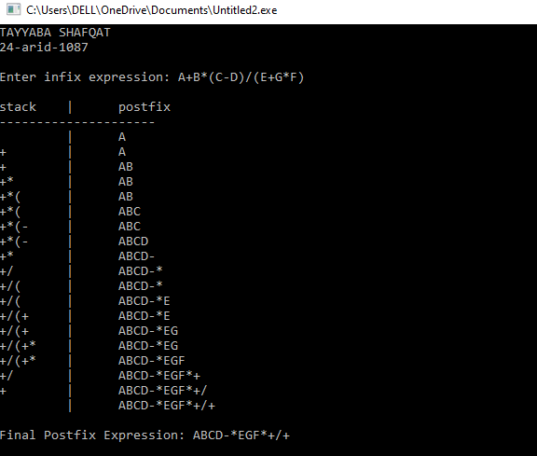
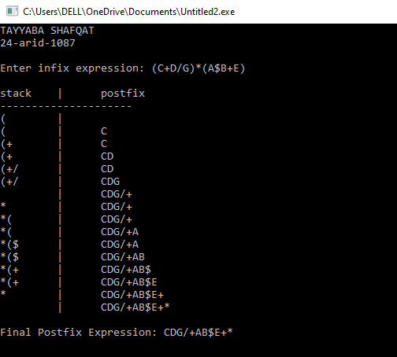

#include<iostream>
#include<conio.h>
#include<cstring>
#include<math.h>
#include<string.h>
using namespace std;
const int arraysize=10;
struct Stack
{
double items[arraysize];
int top;
};
void push(Stack & sp,double d)
{
sp.items[++sp.top]=d;
}
double pop(Stack & so)
{
return so.items[so.top--];
}
void display(Stack & sd)
{
cout<<"The Result of Expression is="<<sd.items[sd.top];
}
double operation(double d1, double d2, char ch2)
{
switch(ch2)
{
case '+': return (d2+d1);
case '-': return (d2-d1);
case '/': return (d2/d1);
case '*': return (d2*d1);
case '$':return pow(d2,d1);
default: return 0;
}
}
void signature(){
cout<<"TAYYABA SHAFQAT "<<endl;
cout<<"24-arid-1087\n"<<endl;
}
int main()
{
signature();
Stack s;
s.top=-1;
char str[]="623+-382/+*2$3+";
char ch;
for(int i=0;i<(int)strlen(str);i++)
{
ch=str[i];
if(ch>='0'&&ch<='9')
push(s,ch-'0'); // coversion into int
else
if(ch=='+'||ch=='-'||ch=='/'||ch=='*'||ch=='$')
{
double oprnd1=pop(s);
double oprnd2=pop(s);
double value=operation(oprnd1,oprnd2,ch);
push(s,value);
}
else
cout<<"\nInvalid Character!";
}
display(s);
getch();
return 0;
}
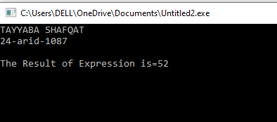

Lab-7
Parenthesis matching validation implementation
Q. No. 1: Implement the parenthesis matching in mathematical expressions using C++.
#include<iostream>
#include<cstring>
using namespace std;
const int size = 20;
struct stack{
char arr[size];
int top;
};
bool isempty(stack &st){
return (st.top==-1);
}
void push(stack &st, char v){
st.arr[++st.top]=v;
}
void pop(stack &st){
if(!isempty(st))
st.top--;
}
bool check(stack &st, const char exp[]){
char symbol;
for(int i=0;i<strlen(exp);i++){
symbol=exp[i];
if(symbol=='('){
push(st,symbol);
}
else{
if(symbol==')'){
if(isempty(st)){
return false;
}
pop(st);
}
}
}
return isempty(st);
}
void signature(){
cout<<"TAYYABA SHAFQAT "<<endl;
cout<<"24-arid-1087\n"<<endl;

}
int main(){
signature();
stack st;
st.top=-1;
cout<<"enter your expression: ";
char exp[size];
cin>>exp;
if(check(st,exp)){
cout<<"Valid expression";
}
else{
cout << "Invalid expression";
}
return 0;}
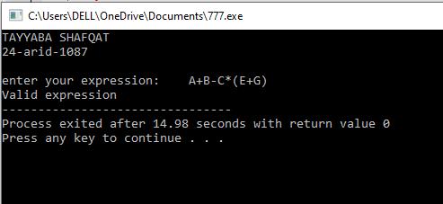

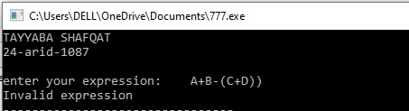

Lab-8
Implementation of queue operations, SJF& Double Ended Queue
Q. No. 1: Implement the Shortest Job First as Ascending Priority Queue using C++ and array based queue.
#include <iostream>
using namespace std;
class Queue {
int item[5];
int front;
int rear;
public:
Queue() {
front = 0;
rear = -1;
}
bool isempty() {
if (front > rear)
return true;
return false;
}
bool isfull() {
if (rear >= 4)
return true;
return false;
}
void compact() {
if (front == 0) return;
if (front > rear) {
front = 0;
rear = -1;
return;
}
int j = 0;
for (int i = front; i <= rear; i++) {
item[j++] = item[i];
}
rear = j - 1;
front = 0;

for (int k = rear + 1; k < 5; k++) item[k] = 0;
}

void insert(int x) {
if (isfull()) {

compact();
if (isfull()) {
cout << "Queue is full, cannot insert " << x << endl;
return;
}
}
item[++rear] = x;
}

int remove() {
if (isempty()) {
cout << "Queue is empty, nothing to remove" << endl;
return -1;
}
return item[front++];
}

void apinsert(int x) {

if (isfull()) {
compact();
if (isfull()) {
cout << "Queue is full, cannot insert " << x << endl;
return;
}
}

if (isempty()) {
insert(x);
return;
}

if (x >= item[rear]) {
insert(x);
return;
}
Queue q2;
while (!isempty()) {
int t = remove();
if (x < t) {
q2.insert(x);
q2.insert(t);
break;
} else {
q2.insert(t);
}
}
while (!isempty())
q2.insert(remove());
front = 0;
rear = -1;

while (!q2.isempty())
insert(q2.remove());
}

void dislpay() {

for (int k = 4; k > rear; k--)
cout << "\nEmpty";

if (isempty()) {
cout << "\nQueue is empty";
} else {
for (int i = rear; i >= front; i--)
cout << endl << item[i];
}

for (int j = (front - 1); j >= 0; j--)
cout << "\nEmpty";
cout << endl;
}
};
void signature(){
cout<<"TAYYABA SHAFQAT "<<endl;
cout<<"24-arid-1087\n"<<endl;

}
int main()
{
Queue q1;
char repeat = 'y';
signature();
do {
int input;
cout << "1) Press '1' to insert (apinsert): " << endl;
cout << "2) Press '2' to remove: " << endl;
cout << "3) Press '3' to Display: " << endl;
cin >> input;
switch (input) {
case 1: {
int num;
cout << "Enter Number: ";
cin >> num;

q1.apinsert(num);
break;
}

case 2: {
if (q1.isempty())
cout << "\nThe queue is already empty";
else {
int removed = q1.remove();
if (removed != -1)
cout << "\nThe removed value is: " << removed;
}
break;
}
case 3: {
q1.dislpay();
break;
}
default:
cout << "\nInvalid Option";
}
cout << "\nRepeat: y/n..";
cin >> repeat;
} while (repeat == 'y');
return 0;
}
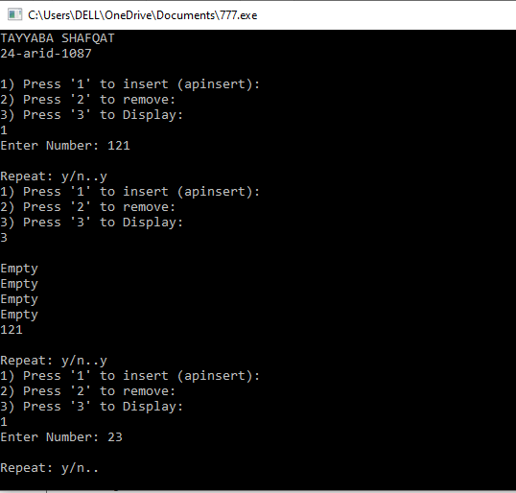
Q. No. 2: Implement the double ended input restricted array based Queue using C++.
#include<iostream>
using namespace std;

const int size = 10;

struct DEQueue {
int arr[size];
int front;
int rear;
};

bool isFull(DEQueue &q) {
return q.rear == size - 1;
}

bool isEmpty(DEQueue &q) {
return q.rear < q.front;
}

void insert_front(DEQueue &q, int value) {
if (isFull(q)) {
cout << "Queue is full, cannot insert at front!" << endl;
return;
}

// Shift all elements to right to make space at index 0
for (int i = q.rear; i >= q.front; i--) {
q.arr[i + 1] = q.arr[i];
}

q.arr[q.front] = value;
q.rear++;

cout << value << " inserted at front." << endl;
}

void insert_rear(DEQueue &q, int value) {
if (isFull(q)) {
cout << "Queue is full, cannot insert at rear!" << endl;
return;
}

q.rear++;
q.arr[q.rear] = value;

cout << value << " inserted at rear." << endl;
}

int remove_front(DEQueue &q) {
if (isEmpty(q)) {
cout << "Queue is empty, cannot remove from front!" << endl;
return -1;
}

int val = q.arr[q.front];

// Shift all elements one step left
for (int i = q.front; i < q.rear; i++) {
q.arr[i] = q.arr[i + 1];
}

q.rear--;

cout << val << " removed from front." << endl;
return val;
}

int remove_rear(DEQueue &q) {
if (isEmpty(q)) {
cout << "Queue is empty, cannot remove from rear!" << endl;
return -1;
}

int val = q.arr[q.rear];
q.rear--;

cout << val << " removed from rear." << endl;
return val;
}

void display(DEQueue &q) {
if (isEmpty(q)) {
cout << "Queue is empty." << endl;
return;
}

cout << "Queue elements: ";
for (int i = q.front; i <= q.rear; i++) {
cout << q.arr[i] << " ";
}
cout << endl;
}
void signature(){
cout<<"TAYYABA SHAFQAT "<<endl;
cout<<"24-arid-1087\n"<<endl;

}
int main() {
DEQueue q;
q.front = 0;
q.rear = -1;
signature();
int choice, val;

while (true) {
cout << "\n=== Double Ended Queue Menu ===" << endl;
cout << "1. Insert at Front" << endl;
cout << "2. Insert at Rear" << endl;
cout << "3. Remove from Front" << endl;
cout << "4. Remove from Rear" << endl;
cout << "5. Display Queue" << endl;
cout << "6. Exit" << endl;
cout << "Enter your choice: ";
cin >> choice;

switch (choice) {
case 1:
cout << "Enter value to insert at front: ";
cin >> val;
insert_front(q, val);
break;

case 2:
cout << "Enter value to insert at rear: ";
cin >> val;
insert_rear(q, val);
break;

case 3:
remove_front(q);
break;

case 4:
remove_rear(q);
break;

case 5:
display(q);
break;

case 6:
cout << "Exiting..." << endl;
return 0;

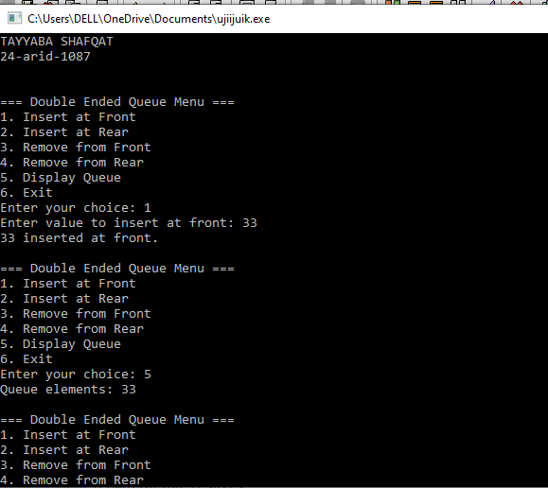
default:
cout << "Invalid choice!" << endl;
}
}

return 0;
}

Lab-9
Linklist implementation using primitive functions
Q. No. 1: Implement the linklist based Stack using C++.
#include <iostream>
using namespace std;
const int SIZE=5;
struct queue {
int arr[SIZE];
int front, rear;
};
void initqueue(queue &q) {
q.front = 0;
q.rear = -1;
}
bool isempty(queue &q) {
return (q.rear == -1);
}
bool isfull(queue &q) {
return (q.rear == SIZE - 1);
}
void insert(queue &q, int value) {
if (isfull(q)) {
cout << "queue is FULL" << value << endl;
return;
}
q.rear++;
q.arr[q.rear] = value;
cout << value << " inserted into queue." << endl;
}
void remove(queue &q) {
if (isempty(q)) {
cout << "queue is empty" << endl;
return;
}
cout << q.arr[q.front] << " removed from queue." << endl;
for (int i = 0; i < q.rear; i++) {
q.arr[i] = q.arr[i + 1];
}
q.rear--; // shrink the queue
}
void display(queue &q) {
if (isempty(q)) {
cout << "queue is EMPTY!" << endl;
return;
}
cout << "queue elements: ";
for (int i = q.front; i <= q.rear; i++) {
cout << q.arr[i] << " ";
}
cout << endl;
}
void signature(){
cout<<"TAYYABA SHAFQAT"<<endl;
cout<<"24-arid-1087\n"<<endl;
}
int main() {
queue q;
initqueue(q);
int choice, value;
signature();
do {
cout << "\n====== SIMPLE QUEUE MENU ======\n";
cout << "1. Insert\n";
cout << "2. Remove\n";
cout << "3. Display\n";
cout << "4. Exit\n";
cout << "Enter choice: ";
cin >> choice;

switch (choice) {
case 1:
cout << "Enter value: ";
cin >> value;
insert(q,value);
break;
case 2:
remove(q);
break;
case 3:
display(q);
break;
case 4:
cout << "Exiting...\n";
break;

default:
cout << "Invalid choice.\n";
}
} while (choice != 4);
return 0;
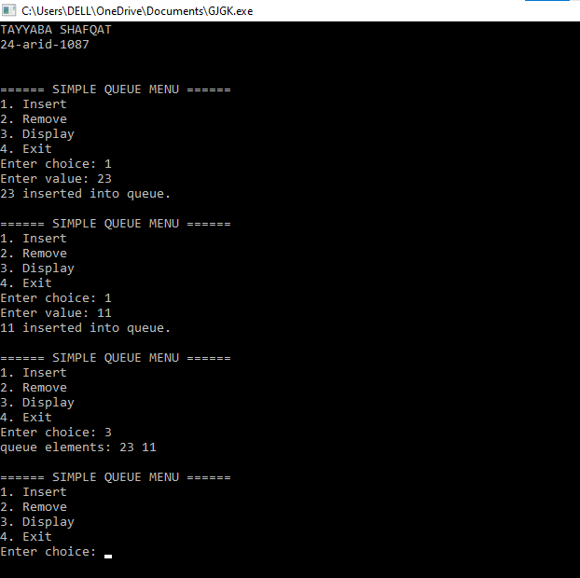
}
Q. No. 2: Implement the linklist based Queue using C++.
#include<iostream>
using namespace std;
struct Node{
int data;
Node* next;
};
class list{
Node* front;
Node* rear;
public:
list(){
front=NULL;
rear=NULL;
}
void insert(int val){
Node* newNode=new Node;
newNode->data=val;
newNode->next=NULL;
if(front==NULL){
front=rear=newNode;
}
else{
rear->next=newNode;
rear=newNode;
}
}
void remove(){
if(front==NULL){
cout<<"LL is empty"<<endl;
return;
}
Node* temp=front;
front=front->next;

// If list becomes empty after deletion
if(front == NULL) {
rear = NULL;
}
temp->next=NULL; //so no next node adress is stored
delete temp;
}
void print(){
Node* temp=front;
while(temp!=NULL){
cout<<temp->data<<" ";
temp=temp->next;
}
}
};
void signature(){
cout<<"TAYYABA SHAFQAT "<<endl;
cout<<"24-arid-1087\n"<<endl;

}
int main(){
list ll;
int choice;
int value;
signature();
do {
cout << "\n1. Insert\n";
cout << "2. Remove\n";
cout << "3. Display\n";
cout << "4. Exit\n";
cout << "Enter choice: ";
cin >>choice;
switch (choice) {
case 1:
cout << "Enter value: ";
cin >> value;
ll.insert(value);
break;
case 2:
ll.remove();
break;
case 3:
ll.print();
break;
case 4:
cout << "Exiting...\n";
break;
default:
cout << "Invalid choice.\n";
}
} while (choice != 4);
return 0;
}
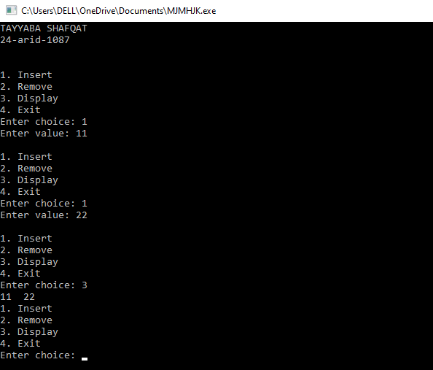

Lab-8
Queue modification as a Circular queue and Priority queue
Q. No. 1: Implement the linklist based Circular Queue using C++.
#include <iostream>
using namespace std;
struct Node {
int data;
Node* next;
};

class cqueueLinklist {
private:
Node* rear;
public:
cqueueLinklist() {
rear = NULL;
}
bool isEmpty() {
return (rear == NULL);
}
void insert(int value) {
Node* temp = new Node;
temp->data = value;
if (rear == NULL) {
rear = temp;
rear->next = rear;
} else {
temp->next = rear->next;
rear->next = temp;
rear = temp;
}
cout << value << " inserted into circular queue.\n";
}
void remove() {
if (isEmpty()) {
cout << "Queue is EMPTY! Nothing to remove.\n";
return;
}
Node* front = rear->next;
int value = front->data;
if (rear == front) {
rear = NULL;
} else {
rear->next = front->next;
}
delete front;
cout << value << " removed from circular queue.\n";
}
int queueFront() {
if (isEmpty()) {
cout << "Queue is EMPTY!\n";
return -1;
}
return rear->next->data;
}
void display() {
if (isEmpty()) {
cout << "Queue is EMPTY!\n";
return;
}
Node* temp = rear->next;
cout << "Queue elements: ";

do {
cout << temp->data << " ";
temp = temp->next;
} while (temp != rear->next);

cout << endl;
}
};
void signature(){
cout<<"TAYYABA SHAFQAT "<<endl;
cout<<"24-arid-1087\n"<<endl;
}

int main() {
cqueueLinklist cq;
int choice, value;
char repeat = 'y';
signature();
do {
cout << "\n===== CIRCULAR QUEUE MENU =====\n";
cout << "1. Insert\n";
cout << "2. Remove\n";
cout << "3. Queue Front\n";
cout << "4. Display\n";
cout << "5. Exit\n";
cout << "Enter choice: ";
cin >> choice;

switch (choice) {
case 1:
cout << "Enter value to insert: ";
cin >> value;
cq.insert(value);
break;

case 2:
cq.remove();
break;

case 3:
value = cq.queueFront();
if (value != -1)
cout << "Front element is: " << value << endl;
break;

case 4:
cq.display();
break;

case 5:
cout << "Exiting...\n";
repeat = 'n';
break;

default:
cout << "Invalid choice!\n";
}
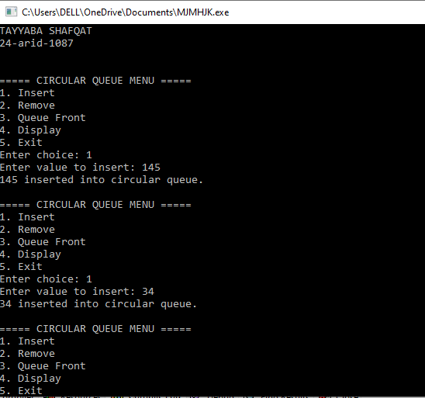
} while (repeat == 'y');
return 0;
}

Q. No. 2: Implement the linklist based Priority Queue using C++.
#include <iostream>
using namespace std;

struct Node {
int data;
int priority;
Node* next;
};
class P_QueueLL {
private:
Node* front;
public:
P_QueueLL() {
front = NULL;
}
bool isEmpty() {
return (front == NULL);
}
void priority_Insert(int value, int prio) {
Node* temp = new Node;
temp->data = value;
temp->priority = prio;
temp->next = NULL;
if (isEmpty() || prio < front->priority) {
temp->next = front;
front = temp;
cout << value << " inserted at front\n";
return;
}
Node* p = front;
while (p->next != NULL && p->next->priority <= prio) {
p = p->next;
}

temp->next = p->next;
p->next = temp;
cout << value << " inserted based on priority\n";
}
void remove() {
if (isEmpty()) {
cout << "Queue is EMPTY!\n";
return;
}
Node* temp = front;
int value = temp->data;
front = front->next;
delete temp;
cout << value << " removed\n";
}
int queueFront() {
if (isEmpty()) {
cout << "Queue is EMPTY!\n";
return -1;
}
return front->data;
}
void display() {
if (isEmpty()) {
cout << "Queue is EMPTY!\n";
return;
}
Node* temp = front;
cout << "Queue elements (data:priority): ";
while (temp != NULL) {
cout << temp->data << ":" << temp->priority << " ";
temp = temp->next;
}
cout << endl;
}
};
void signature(){
cout<<"TAYYABA SHAFQAT "<<endl;
cout<<"24-arid-1087\n"<<endl;
}
int main() {
signature();
P_QueueLL pq;
int choice, value, prio;
char repeat = 'y';
do {
cout << "\n1. Priority Insert\n2. Remove\n3. Queue Front\n4. Display\n5. Exit\nEnter choice: ";
cin >> choice;

switch (choice) {
case 1:
cout << "Enter value: ";
cin >> value;
cout << "Enter priority ";
cin >> prio;
pq.priority_Insert(value, prio);
break;
case 2:
pq.remove();
break;
case 3:
value = pq.queueFront();
if (value != -1)
cout << "Front element is: " << value << endl;
break
case 4:
pq.display();
break;
case 5:
repeat = 'n';
break;
default:
cout << "Invalid choice!\n";
}
} while (repeat == 'y');
return 0;}
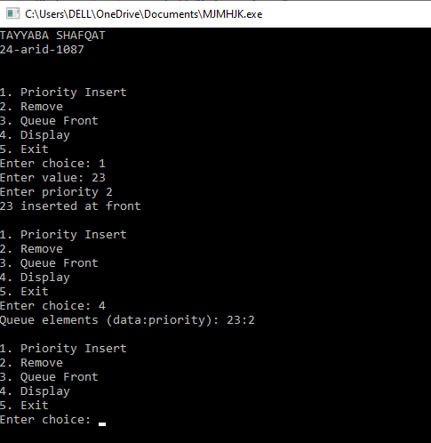

Lab-9
Implementation of doubly linklist
Q. No. 1: Implement the DoublyLinklist based Queue using C++.
#include <iostream>
using namespace std;

struct Node {
int data;
Node* previous;
Node* next;
};
class dqueueLinklist {
private:
Node* front;
Node* rear;
public:
dqueueLinklist() {
front = rear = NULL;
}
bool isEmpty() {
return front == NULL;
}
void insert(int x) {
Node* ptr = new Node;
ptr->data = x;
ptr->next = ptr->previous = NULL;
if (rear == NULL) {
front = rear = ptr;
} else {
ptr->previous = rear;
rear->next = ptr;
rear = ptr;
}
cout << x << " inserted into queue.\n";
}
void remove() {
if (isEmpty()) {
cout << "Queue is EMPTY! Nothing to remove.\n";
return;
}
Node* temp = front;
int value = temp->data;
if (front == rear) {
front = rear = NULL;
} else {
front = front->next;
front->previous = NULL;
}
delete temp;
cout << value << " removed from queue.\n";
}
int queueFront() {
if (isEmpty()) {
cout << "Queue is EMPTY!\n";
return -1;
}
return front->data;}
void display() {
if (isEmpty()) {
cout << "Queue is EMPTY!\n";
return;
}
Node* current = front;
cout << "Queue elements: ";
while (current != NULL) {
cout << current->data << " ";
current = current->next;
}
cout << endl;
}
};
void signature(){
cout<<"TAYYABA SHAFQAT "<<endl;
cout<<"24-arid-1087\n"<<endl;
}
int main() {
dqueueLinklist dq;
int choice, value;
char repeat = 'y';
signature();
do {
cout << "1. Insert\n2. Remove\n3. Queue Front\n4. Display\n5. Exit\nEnter choice: ";
cin >> choice;
switch (choice) {
case 1:
cout << "Enter value to insert: ";
cin >> value;
dq.insert(value);
break;
case 2:
dq.remove();
break;
case 3:
value = dq.queueFront();
if (value != -1)
cout << "Front element is: " << value << endl;
break;
case 4:
dq.display();
break;
case 5:
repeat = 'n';
break;
default:
cout << "Invalid choice!\n";
}
} while (repeat == 'y');
return 0;
}
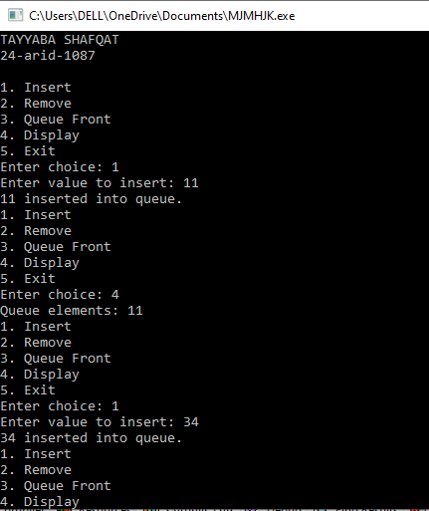

Lab-10

Binary Search Tree implementation
Q. No. 1: Implement the Binary search tree using C++.
#include <iostream>
using namespace std;
struct node {
int data;
node* left;
node* right;
};
class bst {
node* first;
node* removeNode(node* curr, int value) {
if (curr == NULL) return NULL;

if (value < curr->data)
curr->left = removeNode(curr->left, value);
else if (value > curr->data)
curr->right = removeNode(curr->right, value);
else {
if (curr->left == NULL) {
node* temp = curr->right;
delete curr;
return temp;
} else if (curr->right == NULL) {
node* temp = curr->left;
delete curr;
return temp;
}
node* temp = findMin(curr->right);
curr->data = temp->data;
curr->right = removeNode(curr->right, temp->data);
}
return curr;
}
node* findMin(node* curr) {
while (curr && curr->left != NULL)
curr = curr->left;
return curr;
}
public:
bst() {
first = NULL;
}
void insert(int d) {
node* ptr = new node;
ptr->data = d;
ptr->left = ptr->right = NULL;

if (first == NULL) {
first = ptr;
} else {
node* curr = first;
node* insertn = NULL;
int flag;
while (curr != NULL) {
insertn = curr;
if (d >= curr->data) {
flag = 1;
curr = curr->right;
} else {
flag = 0;
curr = curr->left;
}
}
if (flag == 1)
insertn->right = ptr;
else
insertn->left = ptr;
}
}
void remove(int value) {
first = removeNode(first, value);
}
void displayPreorder(node* temp) {
if (temp == NULL) return;
cout << temp->data << " ";
displayPreorder(temp->left);
displayPreorder(temp->right);
}

void displayInorder(node* temp) {
if (temp == NULL) return;
displayInorder(temp->left);
cout << temp->data << " ";
displayInorder(temp->right);
}
void displayPostorder(node* temp) {
if (temp == NULL) return;
displayPostorder(temp->left);
displayPostorder(temp->right);
cout << temp->data << " ";
}
node* get() {
return first;
}
int bstRoot() {
if (first == NULL) return -1;
return first->data;
}
};
void signature(){
cout<<"tayyaba shafqat "<<endl;
cout<<"24-arid-1087\n"<<endl;
}
int main() {
bst b;
signature();
b.insert(45);
b.insert(88);
b.insert(15);
b.insert(60);
b.insert(11);
b.insert(25);
b.insert(6);
b.insert(21);
b.insert(30);
cout << "Displaying BST in Preorder:\n";
b.displayPreorder(b.get());
cout << "\n\nDisplaying BST in Inorder:\n";
b.displayInorder(b.get());
cout << "\n\nDisplaying BST in Postorder:\n";
b.displayPostorder(b.get());
b.remove(11);
b.remove(45);
b.remove(25);
cout << "\n\nAfter removals:\n";
cout << "Preorder: ";
b.displayPreorder(b.get());
cout << "\nInorder: ";
b.displayInorder(b.get());
cout << "\nPostorder: ";
b.displayPostorder(b.get());
cout << endl;
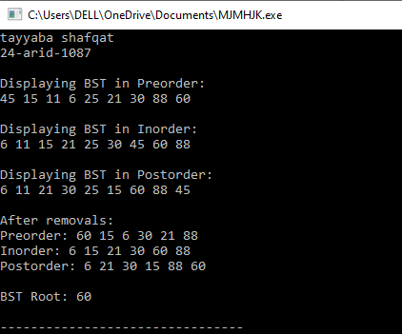 cout << "\nBST Root: " << b.bstRoot() << endl; return 0;}

Lab-11
Max Heap and Heap Sort implementation
Q. No. 1: Implement the MaxHeap using C++.
#include <iostream>
using namespace std;
const int SIZE=100;
struct node {
int data;
};
class maxheap {
node heap[SIZE];
int heapSize;
void heapify(int i) {
int largest = i;
int left = 2 * i + 1;
int right = 2 * i + 2;
if (left < heapSize && heap[left].data > heap[largest].data)
largest = left;
if (right < heapSize && heap[right].data > heap[largest].data)
largest = right;
if (largest != i) {
swap(heap[i], heap[largest]);
heapify(largest);
}
}
public:
maxheap() {
heapSize = 0;
}
void insert(int value) {
if (heapSize >= SIZE) {
cout << "Heap is full" << value << endl;
return;
}
int i = heapSize;
heap[i].data = value;
heapSize++;
while (i != 0 && heap[(i - 1) / 2].data < heap[i].data) {
swap(heap[i], heap[(i - 1) / 2]);
i = (i - 1) / 2;
}
}
void remove() {
if (heapSize <= 0) {
cout << "Heap is empty! Nothing to remove.\n";
return;
}
int root = heap[0].data;
heap[0] = heap[heapSize - 1];
heapSize--;
heapify(0);
cout << root << " removed from heap.\n";
}
int maxValue() {
if (heapSize <= 0) {
cout << "Heap is empty.\n";
return -1;
}
return heap[0].data;
}
void display() {
if (heapSize <= 0) {
cout << "Heap is empty.\n";
return;
}
cout << "Heap elements: ";
for (int i = 0; i < heapSize; i++) {
cout << heap[i].data << " ";
}
cout << endl;
}
};
void signature(){
cout<<"tayyaba shafqat "<<endl;
cout<<"24-arid-1087\n"<<endl;

}
int main() {
maxheap h;
signature();
h.insert(50);
h.insert(30);
h.insert(20);
h.insert(40);
h.insert(10);
cout << "Heap after insertions:\n";
h.display();
cout << "Maximum value (root): " << h.maxValue() << endl;
h.remove();
cout << "Heap after removing max:\n";
h.display();
h.insert(60);
cout << "Heap after inserting 60:\n";
h.display();
cout << "Maximum value (root): " << h.maxValue() << endl;
return 0;
}
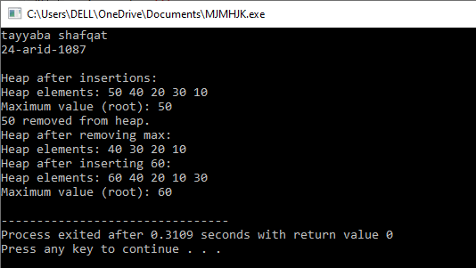

Lab-12
Graph implementation of DFS and BFS search algorithms
Q. No. 1: Implement the Depth First Search (DFS) on graph using C++.
#include <iostream>
using namespace std;
const int size=5;

class dfs {
int adj[size][size];
bool visited[size];
int n; // number of vertices

public:
dfs() {
n = size;
for (int i = 0; i < n; i++) {
visited[i] = false;
for (int j = 0; j < n; j++) {
adj[i][j] = 0; // initialize adjacency matrix
}
}
}
void addEdge(int u, int v) {
adj[u][v] = 1;
adj[v][u] = 1; // undirected graph
}
void dfsUtil(int v) {
visited[v] = true;
cout << v << " ";

for (int i = 0; i < n; i++) {
if (adj[v][i] && !visited[i]) {
dfsUtil(i);
}
}
}

void runDFS(int start) {
// reset visited array
for (int i = 0; i < n; i++) visited[i] = false;

cout << "DFS starting from vertex " << start << ": ";
dfsUtil(start);
cout << endl;
}
void displayAdjMatrix() {
cout << "Adjacency Matrix:\n";
for (int i = 0; i < n; i++) {
for (int j = 0; j < n; j++)
cout << adj[i][j] << " ";
cout << endl;
}
}
};
void signature(){
cout<<"tayyaba shafqat "<<endl;
cout<<"24-arid-1087\n"<<endl;

}
int main() {
dfs g1;
signature();

g1.addEdge(0, 1);
g1.addEdge(0, 2);
g1.addEdge(1, 3);
g1.addEdge(1, 4);
cout << "Graph 1:\n";
g1.displayAdjMatrix();
g1.runDFS(0);
dfs g2;
g2.addEdge(0, 1);
g2.addEdge(0, 3);
g2.addEdge(1, 2);
g2.addEdge(2, 3);
g2.addEdge(3, 4);

cout << "\nGraph 2:\n";
g2.displayAdjMatrix();
g2.runDFS(0);

return 0;
}
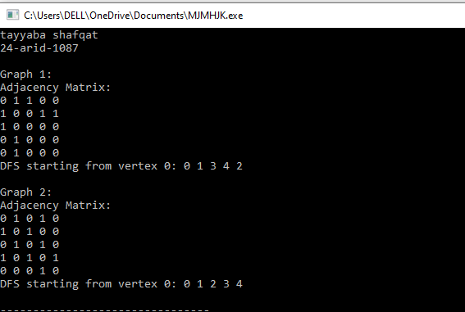
Q. No. 2: Implement the Breadth First Search (DFS) on graph using C++.
#include <iostream>
using namespace std;
const int SIZE= 5
class bfs {
int adj[SIZE][SIZE];
bool visited[SIZE];
int n; // number of vertices
public:
bfs() {
n = SIZE;
for (int i = 0; i < n; i++) {
visited[i] = false;
for (int j = 0; j < n; j++)
adj[i][j] = 0;
}
}
void addEdge(int u, int v) {
adj[u][v] = 1;
adj[v][u] = 1; // undirected graph
}
void runBFS(int start) {
for (int i = 0; i < n; i++)
visited[i] = false;

int queue[SIZE];
int front = 0, rear = -1;
queue[++rear] = start;
visited[start] = true;
cout << "BFS starting from vertex " << start << ": ";
while (front <= rear) {
int v = queue[front++];
cout << v << " ";
for (int i = 0; i < n; i++) {
if (adj[v][i] && !visited[i]) {
queue[++rear] = i;
visited[i] = true;
}
}
}
cout << endl;
}

void displayAdjMatrix() {
cout << "Adjacency Matrix:\n";
for (int i = 0; i < n; i++) {
for (int j = 0; j < n; j++)
cout << adj[i][j] << " ";
cout << endl;
}
}
};
void signature(){
cout<<"tayyaba shafqat "<<endl;
cout<<"24-arid-1087\n"<<endl;

}
int main() {
bfs g1;
signature();
g1.addEdge(0, 1);
g1.addEdge(0, 2);
g1.addEdge(1, 3);
g1.addEdge(1, 4);
cout << "Graph 1:\n";
g1.displayAdjMatrix();
g1.runBFS(0);

bfs g2;
g2.addEdge(0, 1);
g2.addEdge(0, 3);
g2.addEdge(1, 2);
g2.addEdge(2, 3);
g2.addEdge(3, 4);

cout << "\nGraph 2:\n";
g2.displayAdjMatrix();
g2.runBFS(0);

return 0;
}
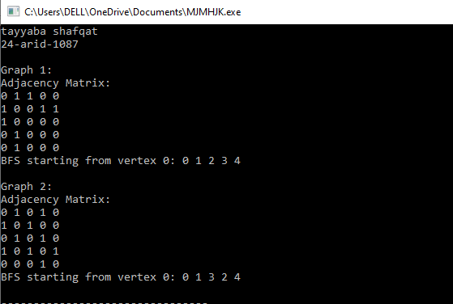

Lab-13
Implementation of shortest path (Warshal Floyd’s algorithm)
Q. No. 1: Implement the Warshal’s Algorithm on graph using C++ to find the path existence between any two pair of nodes.
#include <iostream>
#include <conio.h>
#include <iomanip>
using namespace std;
void header(char *ch[8])
{
cout<<" ";
for(int i=0;i<8;i++)
{
cout<<setw(4)<<ch[i];
}
}
void warshalalgo(int arr[8][8])
{
for(int k=0;k<8;k++)
for(int i=0;i<8;i++)
for(int j=0;j<8;j++)
arr[i][j]|=arr[i][k]& arr[k][j];
}
void display(int arr[8][8],char * ch[8])
{
for(int a=0;a<8;a++)
{
cout<<endl;
cout<<setw(4)<<ch[a];
for(int b=0;b<8;b++)
{
cout<<setw(4)<<arr[a][b];
}
}
cout<<endl;
}

void signature(){
cout<<"tayyaba shafqat "<<endl;
cout<<"24-arid-1087\n"<<endl;
}
int main(){
char *name[8]={"fsd","isd","khi","lhr","mtn","pwr","rwp","swl"};

int city[8][8]={ {1,0,1,0,0,0,0,0},
{0,1,0,0,0,0,0,0},
{0,0,1,0,1,0,0,0},
{1,1,0,1,0,0,0,0},
{1,0,0,1,1,0,0,0},
{0,1,0,0,1,1,0,0},
{0,0,0,0,0,1,1,0},
{1,0,0,0,0,0,0,1}};
signature();
header(name);
display(city,name);
warshalalgo(city);
display(city,name);
getch();
return 0;
}
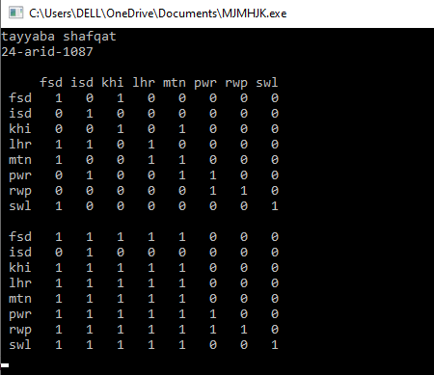

Q. No. 2: Implement the Floyd’s Algorithm on graph using C++ to find the shortest path between any two pair of nodes.
#include <iostream>
using namespace std;

int sum(int x, int y)
{
if (x == -1)
{
return x;
}
if (y == -1)
{
return y;
}
return (x + y);
}
int min(int x, int y)
{
if (x == -1)
{
return y;
}
if (y == -1)
{
return x;
}
if (x < y)
return x;
return y;
}
void signature(){
cout<<"tayyaba shafqat "<<endl;
cout<<"24-arid-1087\n"<<endl;
}
int main()
{ signature();
string names[6] = {"v1", "v2", "v3", "v4", "v5", "v6"};
int matrix[6][6] = {
{0, 7, -1, 2, -1, 6},
{-1, 0, -1, -1, 4, 9},
{-1, -1, 0, 5, -1, 4},
{-1, 4, -1, 0, 6, -1},
{-1, -1, -1, -1, 0, -1},
{-1, -1, -1, -1, -1, 0}};

for (int i = 0; i < 6; i++)
{
cout << "\t" << names[i];
}
cout << endl;

for (int i = 0; i < 6; i++)
{
cout << names[i] << "\t";
for (int j = 0; j < 6; j++)
{

cout << matrix[i][j] << "\t";
}
cout << endl;
}

for (int k = 0; k < 6; k++)
{
for (int i = 0; i < 6; i++)
{

for (int j = 0; j < 6; j++)
{
matrix[i][j] = min(matrix[i][j], sum(matrix[i][k], matrix[k][j]));
}
}
}

cout << endl;

for (int i = 0; i < 6; i++)
{
cout << "\t" << names[i];
}
cout << endl;

for (int i = 0; i < 6; i++)
{
cout << names[i] << "\t";
for (int j = 0; j < 6; j++)
{

cout << matrix[i][j] << "\t";
}
cout << endl;
}

return 0;
}
